1. Original :

http://howtodoinjava.com/jpa/spring-hibernate-jpa-configuration-example/

1. <http://localhost:8087/springjpaexample/employee-module/>

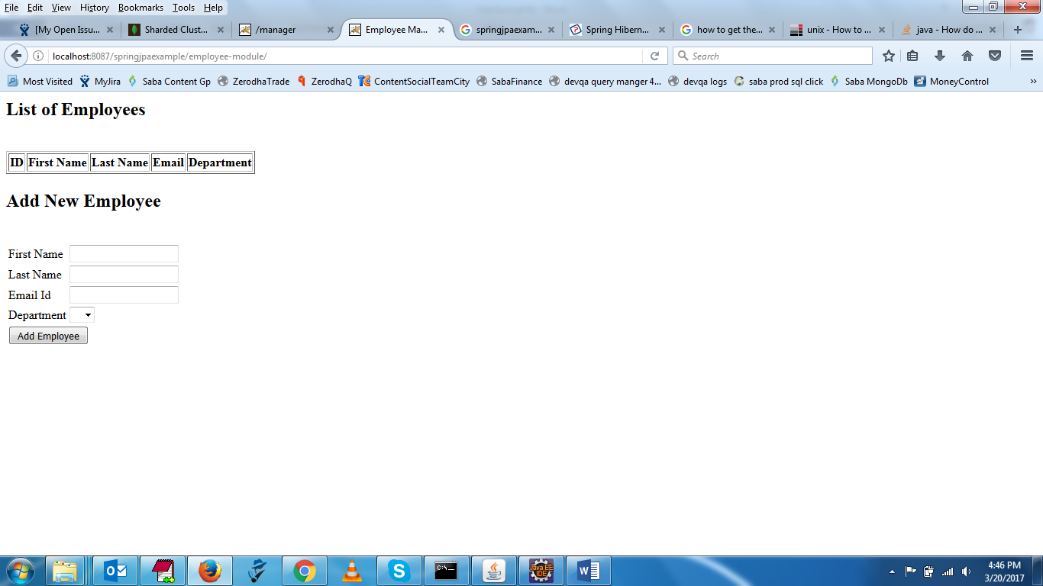s

1. INSERT INTO department values(1, 'IT');

INSERT INTO department values(2, 'Mec');

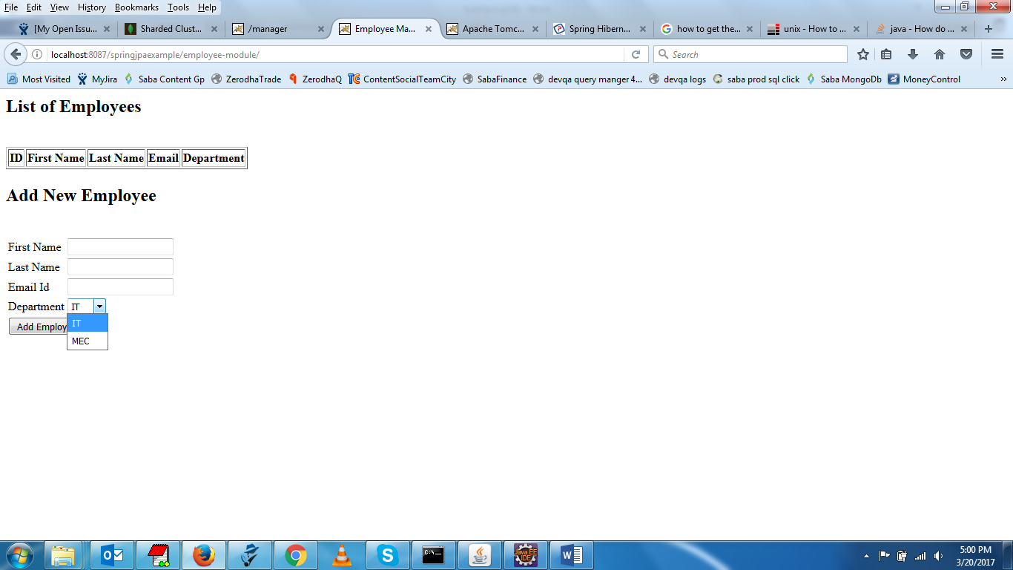

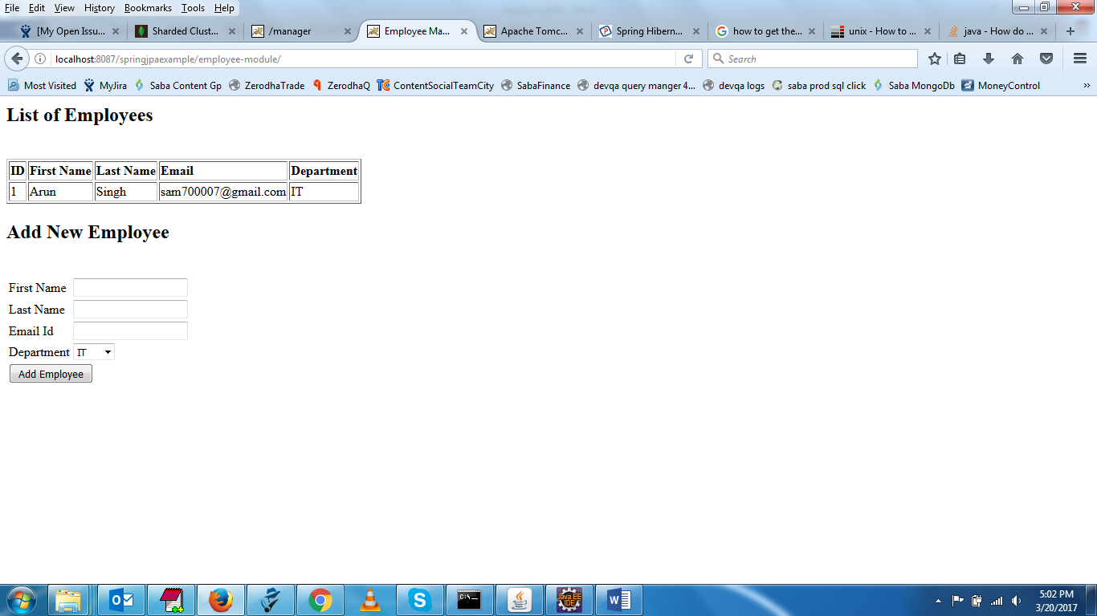

<bean id=*"dataSource"* class=*"org.springframework.jdbc.datasource.DriverManagerDataSource"*>

<property name=*"driverClassName"* value=*"com.mysql.jdbc.Driver"* />

<property name=*"url"* value=*"jdbc:mysql://localhost:3306/db1"* />

<property name=*"username"* value=*"uone"* />

<property name=*"password"* value=*"welcome"* />

</bean>